Dynamic photo-mechanistic modelling of biomass growth and optical density for the cyanobacterium Synechococcus sp. PCC 11901
Bovinille Anye Cho,^{a*} José Ángel Moreno-Cabezuelo,^{b} Lauren A. Mills,^{b} Antonio Del Rio-Chanona,^{c} David J. Lea-Smith,^{b} Dongda Zhang,ª
ªThe University of Manchester, Engineering Building A, Manchester, M13 9PL, UK
^{b}University of East Anglia, Norwich Research Park, Norwich, NR4 7TJ, UK
^{c}Imperial College London, South Kensington Campus, London, SW7 2AZ, UK
*email of the corresponding author: bovinille.anyecho@manchester.ac.uk
Abstract
Fast-growing cyanobacterial species are potential chassis for converting inorganic carbon into biomass and biomolecules for industrial, medical, and herbicidal applications. However, unavailable mechanistic interpretations for the differing bioconversion rates among isolated strains with similar metabolic pathways and transport systems hinders the biotechnological exploitation.
Therefore, this study investigates two strains: Synechococcus sp. PCC 11901, the fastest growing cyanobacterium ever isolated, and Synechocystis sp. PCC 6803, the benchmark cyanobacterial strain, under a wide range of operational light intensities from 300 – 900 µmol photons m⁻² s⁻¹. This study reports three original contributions.
Firstly, strain specific photo-mechanistic influences were embedded into dynamic biomass and optical density (OD750nm) models, too sophisticated to be previously achieved in OD750nm. Secondly, bootstrapping parameter estimation methodology with 3-fold cross validations was utilised to simultaneously identify optimal model parameters and associated confidence intervals. This enabled probabilistic simulations and the thorough validation against unseen experimental datasets. For both species, the simulated errors averaged to less than 19 %, thus demonstrating the model reliability for predicting such highly nonlinear bioprocess dynamics. Thirdly, recounted mechanistic interpretations for the over two-folds faster growth of Synechococcus sp. PCC 11901 compared to Synechocystis sp. PCC 6803 despite the latter’s high light utilisation efficiency.
Hence, these models and findings will benefit strain specific photobioreactor design and upscaling of the future cyanobacterial biotechnology applications to produce biomass and biochemicals of industrial importance.
Keywords: Cyanobacterial photobiotechnology, Synechococcus sp. PCC 11901, Synechocystis sp. PCC 6803, Biomass and Optical density modelling, Bootstraping parameter estimation.
  - Introduction
Cyanobacteria utilises light energy, minimal nutrients, and potentially low-cost waste streams like flue gases (e.g., 4-14 vol% CO₂ from power plants [1]), in technical equipment not requiring arable land, to convert inorganic carbon into biomass and biomolecules for industrial, nutritional, medical, and herbicidal applications [2]. However, commercial viability is dependent on the overall cyanobacterial productivity and product titer being comparable to alternative industrially viable heterotrophic microorganisms. For example, Escherichia coli and Saccharomyces cerevisiae with doubling times of 20 and 90 minutes, respectively [3]. Therefore, significant research efforts have been invested in isolating faster growing cyanobacterial species featuring Synechocystis sp. PCC 6803 (PCC 6803), Synechococcus elongatus PCC 7942, Synechococcus sp. PCC 7002, Synechococcus elongatus UTEX 2973, and Synechococcus sp. PCC 11901 (PCC 11901) with the respective doubling times of 6.6 hours, 4.1 hours, 4.0 hours, 2.1 hours, and 2.0 hours [2–4]. PCC 11901 stands out as fastest growing, accumulating biomass concentrations of up to 33 g DCW L⁻¹ [4] and therefore most promising species for future biotechnology applications. However, both PCC 11901 and PCC 6803 were shown in the literature [3] to have very similar metabolic pathways and transport systems, contradicting their differing doubling times. Whilst in-depth mechanistic analysis utilising estimated biokinetic model parameters could provide additional insights into the physical, biological, chemical, and interacting aspects, such analysis has not been conducted to the best of our knowledge. Literature approaches either (i) directly compared the obtained final optical densities and/or biomass concentrations [4], (ii) compared experimentally measured oxygen evolution and photoinhibition rates [3], and/or (iii) curve fit for the maximum specific growth rates with the experimentally generated datasets of optical densities and/or biomass concentrations [4]. Therefore, resulting doubling times are grossly estimated without accounting for the impact of (i) process equipment (e.g., photobioreactor path length), (ii) operation (e.g., light intensity and light attenuation), and (iii) growth dynamics (e.g., photolimitation, photosaturation and photoinhibition). Excluding (i) to (iii) makes it challenging to directly compare PCC 11901 to the industrially viable heterotrophic microorganisms whereas embedding (i) to (iii) in dynamic cyanobacterial models has been limited to biomass growth pending optical density models. Therefore, these limitations were tackled in this study by embedding the impacts of light intensity, light attenuation, photolimitation, photosaturation and photoinhibition mechanisms in dynamic biomass growth and optical density models. The central aim was to reliably assess the growth dynamics and scalability potential of two cyanobacterial species: PCC 11901 and PCC 6803. In addition, providing in-depth mechanistic discussions to support experimental results and identifying the optimal light intensities for cultivation and biotechnological scalabilities of the strains.
  - Methodology
    - Photobioreactor operation and analytical techniques
The strains were cultured in a MC-1000 multicultivator bioreactor with an internal diameter of 27 mm, aerated with air/5% CO₂ for inorganic carbon supply and bioreactor mixing, maintained at a temperature of 38 °C and illuminated over 300 - 900 µmol photons m⁻² s⁻¹. The protocol for photobioreactor operation, analytical equipment and methods for quantifying optical density and biomass concentration has been detailed in our work [2], thus omitted herein.
    - Mechanistic modelling of biomass concentration
The constructed dynamic models were to embed the sophisticated influences of (i) incident light intensity, (ii) light attenuation, and (iii) photomechanisms (i.e., photolimitation, photosaturation, and photoinhibition) on the various growth phases of the strains. The lag phase was not pronounced due to the starter cultures being adapted to the operational light intensity [2], and the remainder phases (namely, primary growth, secondary growth, and stationary phases) showed differing magnitude of light related influences among the cyanobacterial strains. As per PCC 11901’s biomass modelling, the light related influences are captured with the first term of Eq. (1) meanwhile the light independent endogenous cellular activities were captured by the second term. The light attenuation (Eq. (2)) and all photomechanisms were noticeably embedded in Eq. (1) as supported by the statistically significant student’s t-test (P<0.05) over all the state trajectories. Conversely, PCC 6083’s showed statistical significance for only two to three discrete time points on each growth trajectory, thus Eq. (1) was modified to Eq. (3), eliminating light attenuation and photoinhibition.
$$\frac{dX}{dt}=\frac{u_{m}}{40}∙\sum_{n=1}^{19}{\left(\frac{I_{0}}{I_{0}+k_{s}+\frac{I_{0}^{2}}{k_{i}}}+\frac{2∙I_{\frac{n∙L}{20}}}{I_{\frac{n∙L}{20}}+k_{s}+\frac{I_{\frac{n∙L}{20}}^{2}}{k_{i}}}+\frac{I_{L}}{I_{L}+k_{s}+\frac{I_{L}^{2}}{k_{i}}}\right)}∙X-μ_{d}∙X^{2}$$ | (1)
$$I_{\frac{n∙L}{20}}=I_{0}∙exp\left[-\left(τ∙X+β \right)∙\frac{n∙L}{20}\right]$$ | (2)
$$\frac{dX}{dt}=u_{m}∙\frac{I_{0}}{I_{0}+K_{s}}∙X-μ_{d}∙X^{2}$$ | (3)
where $X$ is the biomass concentration (g L⁻¹), $u_{m}$ is the maximum specific growth rate (h⁻¹), $μ_{d}$ is the decay growth rate (h⁻¹), $I_{0}$ is the incident light intensity (µmol photons m⁻² s⁻¹), $L$ is the light path length (mm), $k_{s}$, $k_{i}$, $β$ and $τ$ are the light saturation (µmol photons m⁻² s⁻¹), light inhibition (µmol photons m⁻² s⁻¹), light scattering (mm⁻¹) and light attenuation (mm² g⁻¹) coefficients respectively.
    - Mechanistic modelling of optical density
The literatures [3,4] presented optical density profiles exhibiting sigmoidal shapes for the Synechococcus and Synechocystis strains. These sigmoidal shapes are typical of bioprocesses experiencing the three (namely, primary growth, secondary growth, and stationary phases) phases modelled herein. Therefore, the model structures for biomass concentration (i.e., Eq. (1) to (3)) and optical density were assumed to be similar, thus the variable ${OD}_{750}$ replaces $X$ for the optical density modelling. However, only pigment dominated light absorption influences captured with Eq. (4) were incorporated in the optical density model. As caveat, $τ$ in Eq. (4) has units (mm⁻¹) unlike (mm² g⁻¹) in Eq. (2).
$$I_{\frac{n∙L}{20}}=I_{0}∙exp\left[-\left(τ∙{OD}_{750}\right)∙\frac{n∙L}{20}\right]$$ | (4)
where${ OD}_{750}$ is the optical density at a wavelength of 750 nm (dimensionless).
    - Dynamic model parameter estimation
To estimate all model parameters, a weighted non-linear least-square regression problem was formulated. The differential equations were numerically discretised with orthogonal collocation over finite elements in time and transformed into a series of non-linear algebraic equations. These were solved with an interior point-based solver (i.e., IPOPT version 3.11.1) through an open-source interface Pyomo within the Python version 3.9 programming environment [2].
  - Results
    - Bootstrapping dynamic parameter estimation results
In addition to identifying all model parameters, the associated confidence intervals were simultaneously estimated with a bootstrapping technique with 3-folds validations. Table 1 shows these optimal parameters to be comparable to those of previous studies [2,5,6], thereby validating the reliability of the presented results. Overall fitting errors (i.e., percentage relative errors (%RE)) were of less than 19.0 %, as presented for PCC 11901’s biomass model in Figure 1, thus capturing the complex nonlinear bioprocess behaviour. Similar fittings were observed for the OD and PCC 6083’models, thus not shown herein.
Table 1: Results of bootstrapping dynamic parameter estimation for the biomass and optical density (OD_{750nm}) models of the two cyanobacterial strains. Model parameter estimates denote the mean of n=3 bootstrapping partitions $±$standard deviations as the parameter confidence intervals. Mean values were comparable to the literature [2,5,6] reported values.
Model parameter | OD₇₅₀ model | Biomass model
PCC 11901
$u_{m}$ (h⁻¹) | 1.99$×$10⁻¹$±$2.86$×$10⁻³ | 1.99$×$10⁻¹$±$5.39$×$10⁻⁴
$μ_{d}$ (h⁻¹) | 6.15$×$10⁻⁴$±$8.94$×$10⁻⁶ | 2.96$×$10⁻³$±$2.64$×$10⁻⁴
$k_{s}$ ($μ$mol photons m⁻² s⁻¹) | 150.0 $±$ 4.08 | 156.67 $±$ 6.24
$k_{i}$ ($μ$mol photons m⁻² s⁻¹) | 3523.33$±$24.94 | 3522.33$±$23.61
$τ$ (mm² g⁻¹) | 48.57 $±$ 1.03 | 208.14 $±$ 6.62
$β$ (mm⁻¹) | na | 3.16$×$10⁻⁷$±$3.07$×$10⁻⁸
PCC 6803
$u_{m}$ (h⁻¹) | 7.9$×$10⁻²$± 2$.65$×$10⁻³ | 7.9$×$10⁻²$± 2$.65$×$10⁻³
$μ_{d}$ (h⁻¹) | 1.57$×$10⁻²$±$3.52$×$10⁻⁴ | 6.54$×$10⁻²$±$1.46$×$10⁻³
$K_{s}$ ($μ$mol photons m⁻² s⁻¹) | 72.84 $±$ 12.74 | 72.84 $±$ 12.74
na: not included in model structure
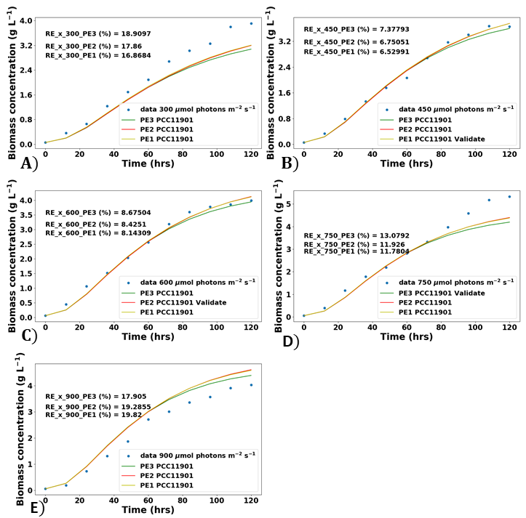
Figure 1: Biomass model fitting results for PCC 11901 at light intensities ($μ$mol photons m⁻² s⁻¹): (A) 300, (B) 450, (C) 600, (D) 750, (E) 900. The percentage relative error (%RE) of each fitting is as indicated.
    - Probabilistic model prediction validations
The performances of the biomass and optical density (OD_{750nm}) models for predicting unseen datasets were deemed necessary to assess their suitability for long-term bioprocess simulation, optimisation, and control. Figure 2 shows the mean model predictions to represent the experimental data points, thereby reliably predicting the complex nonlinear behaviours. Results for optical density (OD_{750nm}) were not presented due to similar trajectories. The uncertainty bands in Figure 2 are observed to grow (i.e., increase of bandwidth size) with time, indicating the models to be responsive to changes of these parameters. However, these parameter changes did not induce large uncertainty bands on the outputs, they are therefore safe for re-estimation during online dynamic bioprocess control [7].
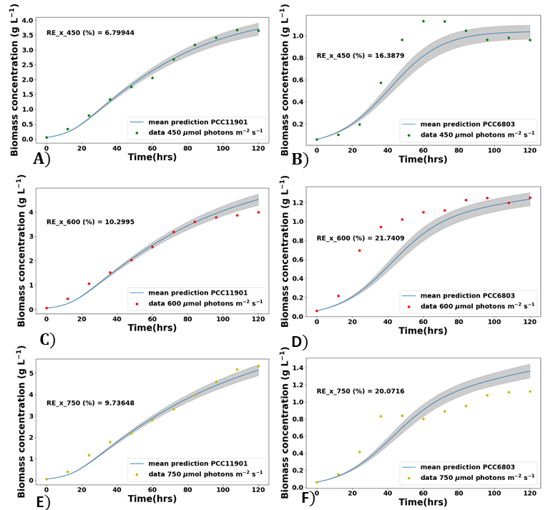
Figure 2: Prediction of biomass models under uncertainty: (A), (C) and (E) for PCC 11901, and (B), (D) and (F) for PCC 6803, at light intensities ($μ$mol photons m⁻² s⁻¹): 450, 600, and 750 which were unseen datasets during the bootstrapping parameter estimation. The percentage relative error (%RE) of each fitting is as indicated in grey.
    - Comparison of the two cyanobacteria strains
Growth characteristics of the two strains in Table 1 showed the maximum specific growth rate of PCC 91101 to be over two-fold higher than that of PCC 6803.The faster growth of PCC 11901 agrees with previous studies [3,4] confirming its superior growth capabilities. PCC 6803’s light saturation coefficient was about two-fold lower than that of PCC 11901, indicating superior light affinity and utilisation efficiency. This unexpected observation was deciphered by analysing the maximum specific growth and decay rates in Table 1, showing similar order of magnitudes for PCC 6083 but over 67-fold lower for PCC 11901. This implies that PCC 11901 was experiencing unbalanced growth, the first time of Eq. (1) dominating (i.e., $u_{m}≫μ_{d}$), whereas that of PCC 6803 was balanced (i.e., $u_{m}\sim μ_{d}$), justifying PCC 11901’s higher growth (i.e., $u_{m_PC11901}>u_{m_PC6803}$) in Table 1.
  - Conclusion
In this paper, mechanistic models capable of simulating the sophisticated influences of (i) incident light intensity, (ii) light attenuation, and (iii) photomechanisms (i.e., photolimitation, photosaturation, and photoinhibition) on two cyanobacteria strains, namely PCC 11901 and PCC 6083, were investigated for biomass growth and Optical density (OD_{750nm}) accumulation. Dynamic OD_{750nm} models embedding (i) to (iii) were previously unavailable, thus not literature validated. Considerable agreements for biomass models were demonstrated, and both OD_{750nm} and biomass model predictions were within 19 % of simulation error for both strains. PCC 11901’s optimal cultivation light intensity was estimated at 735.0 $μ$mol photons m⁻² s⁻¹ whereas that of PCC 6803 was unavailable due to light saturated growth beyond 300 $μ$mol photons m⁻² s⁻¹. Therefore, fluorometry measurements are recommended in future for confirming the light-stressed photosynthetic activities of PCC 6803 within the 300 to 900 $μ$mol photons m⁻² s⁻¹ range.
5. References
[1] Collotta M, Champagne P, Mabee W, Tomasoni G. Wastewater and waste CO2 for sustainable biofuels from microalgae. Algal Res 2018;29:12–21. https://doi.org/10.1016/j.algal.2017.11.013.
[2] Anye Cho B, Moreno-Cabezuelo JÁ, Mills LA, del Río Chanona EA, Lea-Smith DJ, Zhang D. Integrated experimental and photo-mechanistic modelling of biomass and optical density production of fast versus slow growing model cyanobacteria. Algal Res 2023;70. https://doi.org/10.1016/j.algal.2023.102997.
[3] Mills LA, Moreno-Cabezuelo JÁ, Włodarczyk A, Victoria AJ, Mejías R, Nenninger A, et al. Development of a Biotechnology Platform for the Fast-Growing Cyanobacterium Synechococcus sp. PCC 11901. Biomolecules 2022;12:872. https://doi.org/10.3390/biom12070872.
[4] Włodarczyk A, Selão TT, Norling B, Nixon PJ. Newly discovered Synechococcus sp. PCC 11901 is a robust cyanobacterial strain for high biomass production. Commun Biol 2020;3. https://doi.org/10.1038/s42003-020-0910-8.
[5] Balskus EP, Walsh CT. The Genetic and Molecular Basis for Sunscreen Biosynthesis in Cyanobacteria. Science (1979) 2010;329:1653–6. https://doi.org/10.1126/science.1193637.
[6] Lindberg P, Park S, Melis A. Engineering a platform for photosynthetic isoprene production in cyanobacteria, using Synechocystis as the model organism. Metab Eng 2010;12:70–9. https://doi.org/10.1016/j.ymben.2009.10.001.
[7] Anye Cho B, Ross BS, du Toit JP, Pott RWMC, del Río Chanona‬‬‬‬ EA, Zhang D. Dynamic modelling of Rhodopseudomonas palustris biohydrogen production: Perturbation analysis and photobioreactor upscaling. Int J Hydrogen Energy 2021;46:36696–708. https://doi.org/10.1016/j.ijhydene.2021.08.162.

